Modelling the Impact of the Geopolitical Tensions amidst the US-China Trade War on the Global Semiconductor Economy

Tan Zen Sheen

Singapore University of Technology and Design

ESD 40.015 Simulation, Modelling and Analysis

Acknowledgements

**Special Thanks To:**

The Project Team  
Adharsha Sam Edwin Sam Devahi, Ryan Seah Yu Wei, Low Haoron

Academic Professors

Professor Nuno Ribeiro, Professor Yue Mu, Professor Gordon Tan

Contents

Contextual Background 3

Project Overview 4

Basic Supply Chain Flow 5

Regions and their Semiconductor Processes 5

Semiconductor Supply Chain Simulation 7

Past Simulation Supply Chain Network 7

Future Simulation Supply Chain Network 8

Data Collection 11

Production costs and Export Revenues: 11

Simulation Data Logging 12

Data Analysis 12

Exploratory Data Analysis 13

Hypothesis Testing 14

Percentage Change in profits 14

Conclusion 15

Bibliography 16

# Contextual Background

In this Simulation, we will study the impacts of the trade war between the US and China on the Global Economy. Before 2018, America has been a dominant player in the manufacturing supply chain of Semiconductors. Due to lack of technology, research and infrastructure, China relied heavily on America and other countries for the Design, Equipment and Manufacturing of Semiconductor Chips, which has caused several choke points in China’s Semiconductor Supply Chain.

To boost China’s economy amidst the Global Semiconductor Industry, China has invested billions to accelerate research and development of its domestic Semiconductor production and has been involved in certain tactics to push itself forward in the Semiconductor Economy. In 2018, it was reportedly found that Company, Dongfang Jingyuan Electron Ltd, had stolen technology from ASML, a company whose equipment played an integral in the Semiconductor Supply Chain. In doing so, China has advanced its own production of Semiconductors, forming its own infrastructure to manufacture and produce Chips, and even manufacturing advanced hypersonic missiles that threatened the United States' defence. This action angered the US Government and sanctions were imposed against China to hinder its growth in the Semiconductor Economy. In October 2022, the Biden Administration imposed sweeping tech restrictions on China, banning all exports of Semiconductor Chips, Design and Software from US and US-related companies from China.

With the series of events amidst the US-China Trade War, the project aims to analyse the impacts of this Geopolitical Intervention by simulating the past and future of the Global Semiconductor Supply Chain and its impact on the Global Economy.

# Project Overview

Based on the geopolitical context, two Simulations are created for analysis, Past and Future. The Past Simulation is where the United States is the dominant power in the Global Semiconductor Supply Chain network and has supply chain networks with the other four regions. On the other hand, the Future Simulation is where China has set up its own full Semiconductor Supply Chain and but has its supply chain flows cut off from the United States and East Asia, due to sanctions from the United States.

In the Simulations, a basic Supply Chain process of the production of Semiconductors is constructed and used, disregarding the design, equipment and software that are needed in the manufacturing of Chips in the Semiconductor Supply Chain. Through this simulation, the flow of goods through the supply chain processes as well as imports and exports within regions can be visualized. By computing the monthly profits of each region, the data is logged and processed for data analysis. Using R, data visualizations and statistical tests are conducted to determine the significance and magnitude of the Geopolitical Intervention on the Global Economy.

# Basic Supply Chain Flow

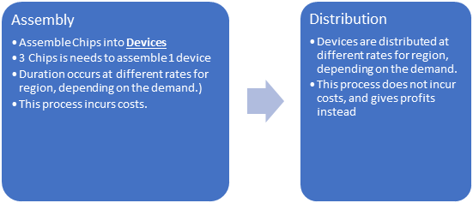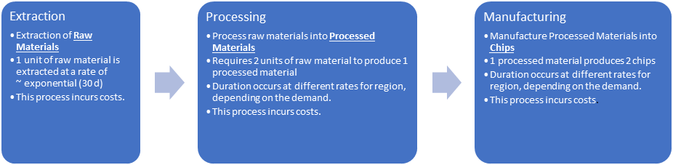

Figure Basic Supply Chain Flow

The basic flow of the simulation consists of 5 processes, Extraction, Processing, Manufacturing, Assembly and Distribution. The process begins with Raw Materials, Silicon Dioxide, which is extracted from sand, and then processed into Wafers, before being manufactured into Semiconductor Chips. Chips are then assembled together to form electronic devices (I.e. Smartphones, Laptops) and distributed for commercial sales.

# Regions and their Semiconductor Processes

For simplicity in this simulation, 5 regions are chosen to simulate the Global Semiconductor Supply Chain. Each region has their own semiconductor processes and would import and export products between each process with each other to ensure a stable network of the Semiconductor supply chain. They also have varying probabilistic distribution rates within each of their semiconductor processes to meet the incoming production.

With the Geopolitical Intervention of the US-China Trade war, the past and future simulations are constructed to mimic the context that has been described earlier, where China sets up its own full production of Semiconductor Processes and has its trade links cut off from the United States and East Asia. This simulation also assumes that Southeast Asia would be an ally of China after the intervention and would also have its trade links cut off from the United States and East Asia after the intervention.

The semiconductor processes of each region as well as their respective probabilistic processing rates are based upon collected data of the processes done by each country and are tweaked accordingly to fit the supply chain flows in the simulation so that each country will meet the demand of incoming products for their semiconductor processes.

Here is a breakdown of the regions, and their processes.

* China
  + Extraction
  + Processing (Future Simulation only)
  + Manufacturing (Future Simulation only)
  + Assembly
  + Distribution
* East Asia
  + Processing
  + Manufacturing
  + Distribution
* Southeast Asia
  + Extraction
  + Assembly
  + Distribution
* America
  + Extraction
  + Processing
  + Manufacturing
  + Assembly
  + Distribution
* Europe
  + Processing
  + Manufacturing
  + Distribution

With respect to the regions used, East Asia consists of South Korea and Taiwan, while Southeast Asia consists of Vietnam and Thailand.

# Semiconductor Supply Chain Simulation

In Simulating the Global Semiconductor Supply Chain, the Discrete Event Simulation Software, JaamSim is used. The Simulation is designed to, at best, follow the geographical locations of regions in the real world. However, due to the spherical shape of the earth and for the sake of simplicity, there are no supply chain connections between Europe and Asia in the Simulation, and East Europe is also excluded from Europe. The map of the simulation is designed as such:

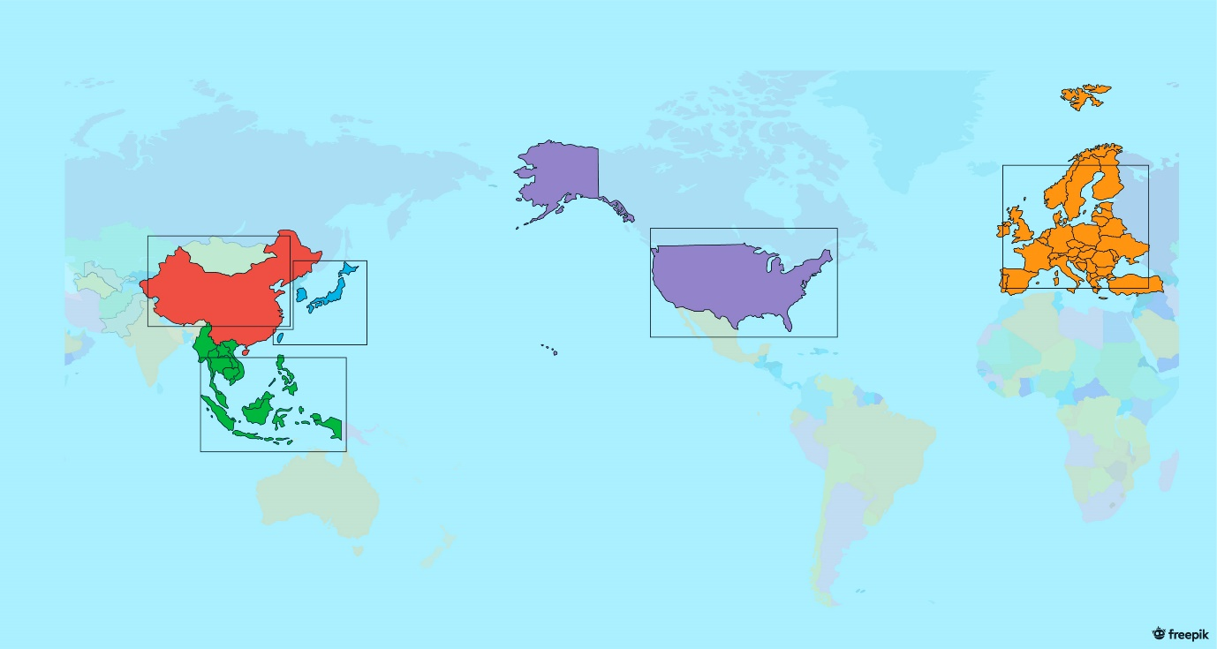

Figure World Map of Semiconductor Supply Chain Simulation

Two different supply chain networks are constructed for each Simulation, Past and Future.

## Past Simulation Supply Chain Network

The Past Simulation simulates the scenario of US being the dominant player in the Semiconductor Industry, with supply chain links with all other regions. The supply chain flows between regions are constructed as such:

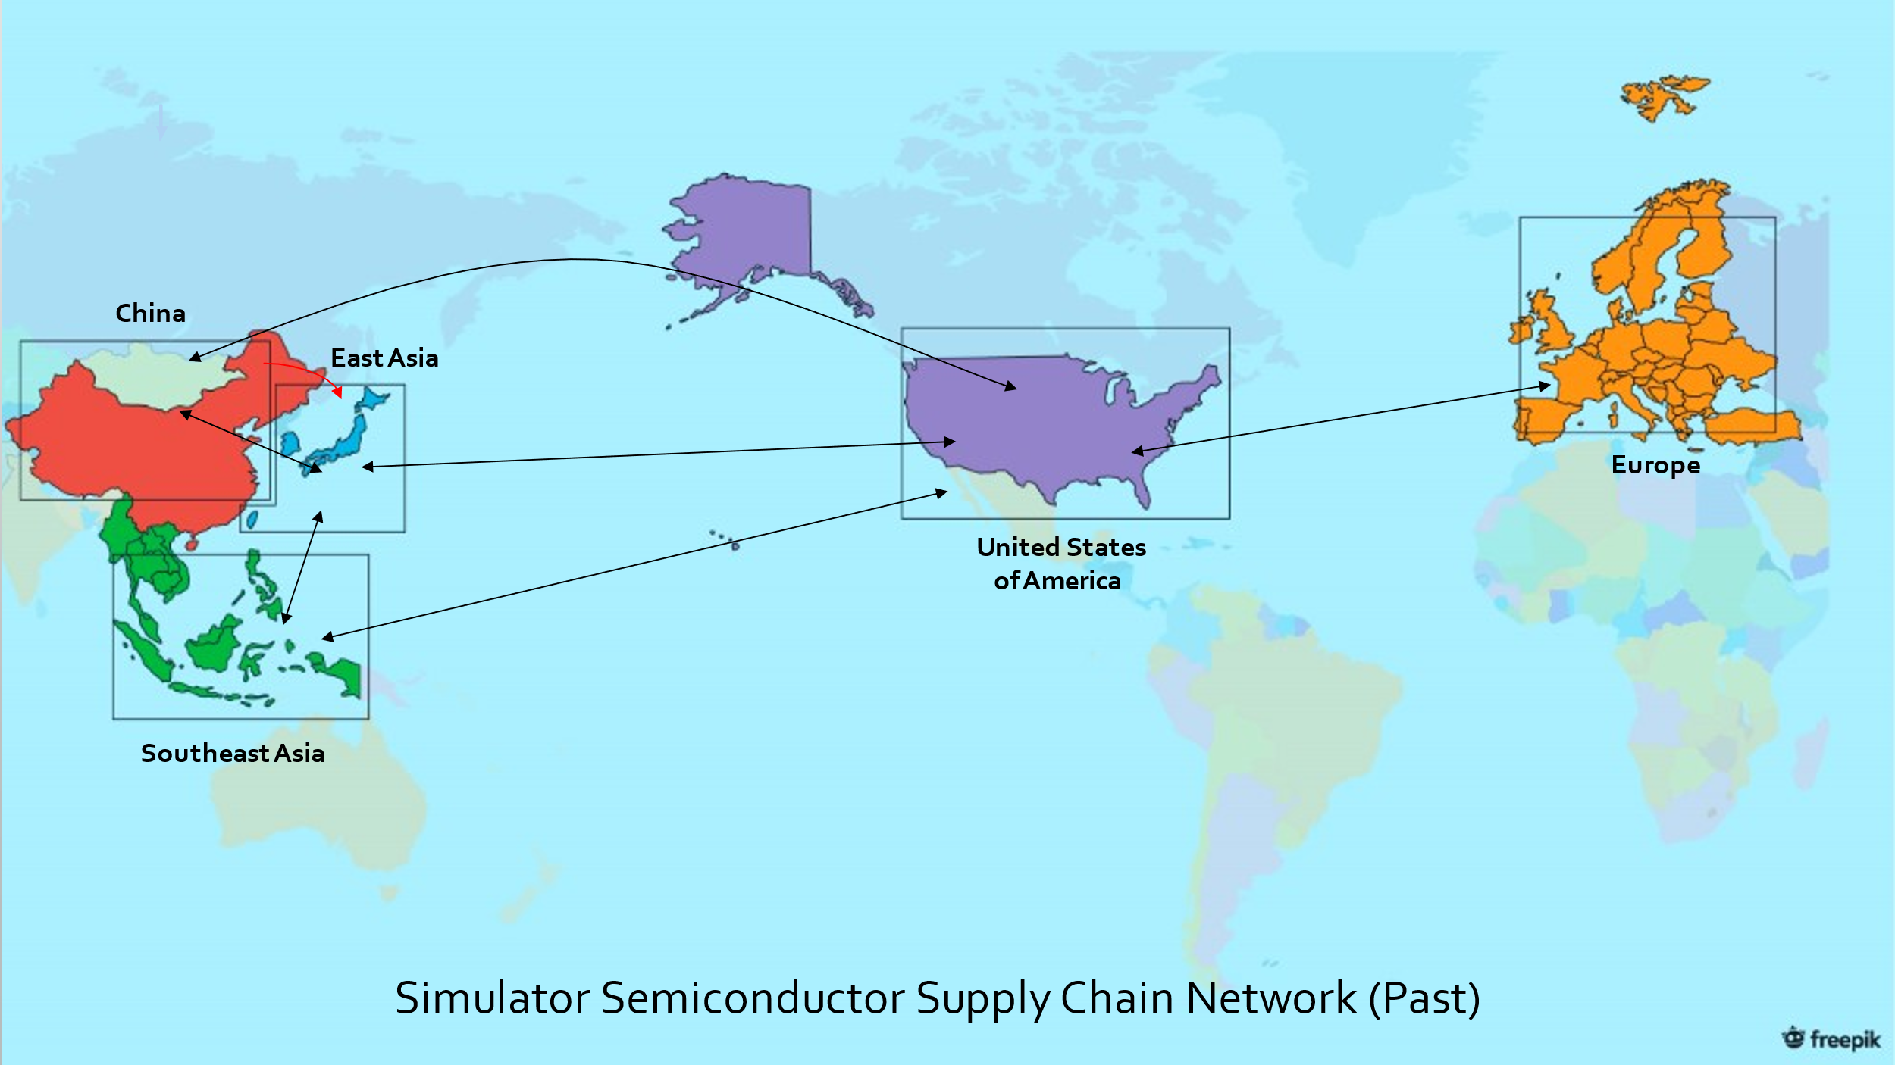

Figure Diagram of inter-region supply chain connections of Past Simulation

The connection of Semiconductor Supply Chain Processes within and between each region is as follows:

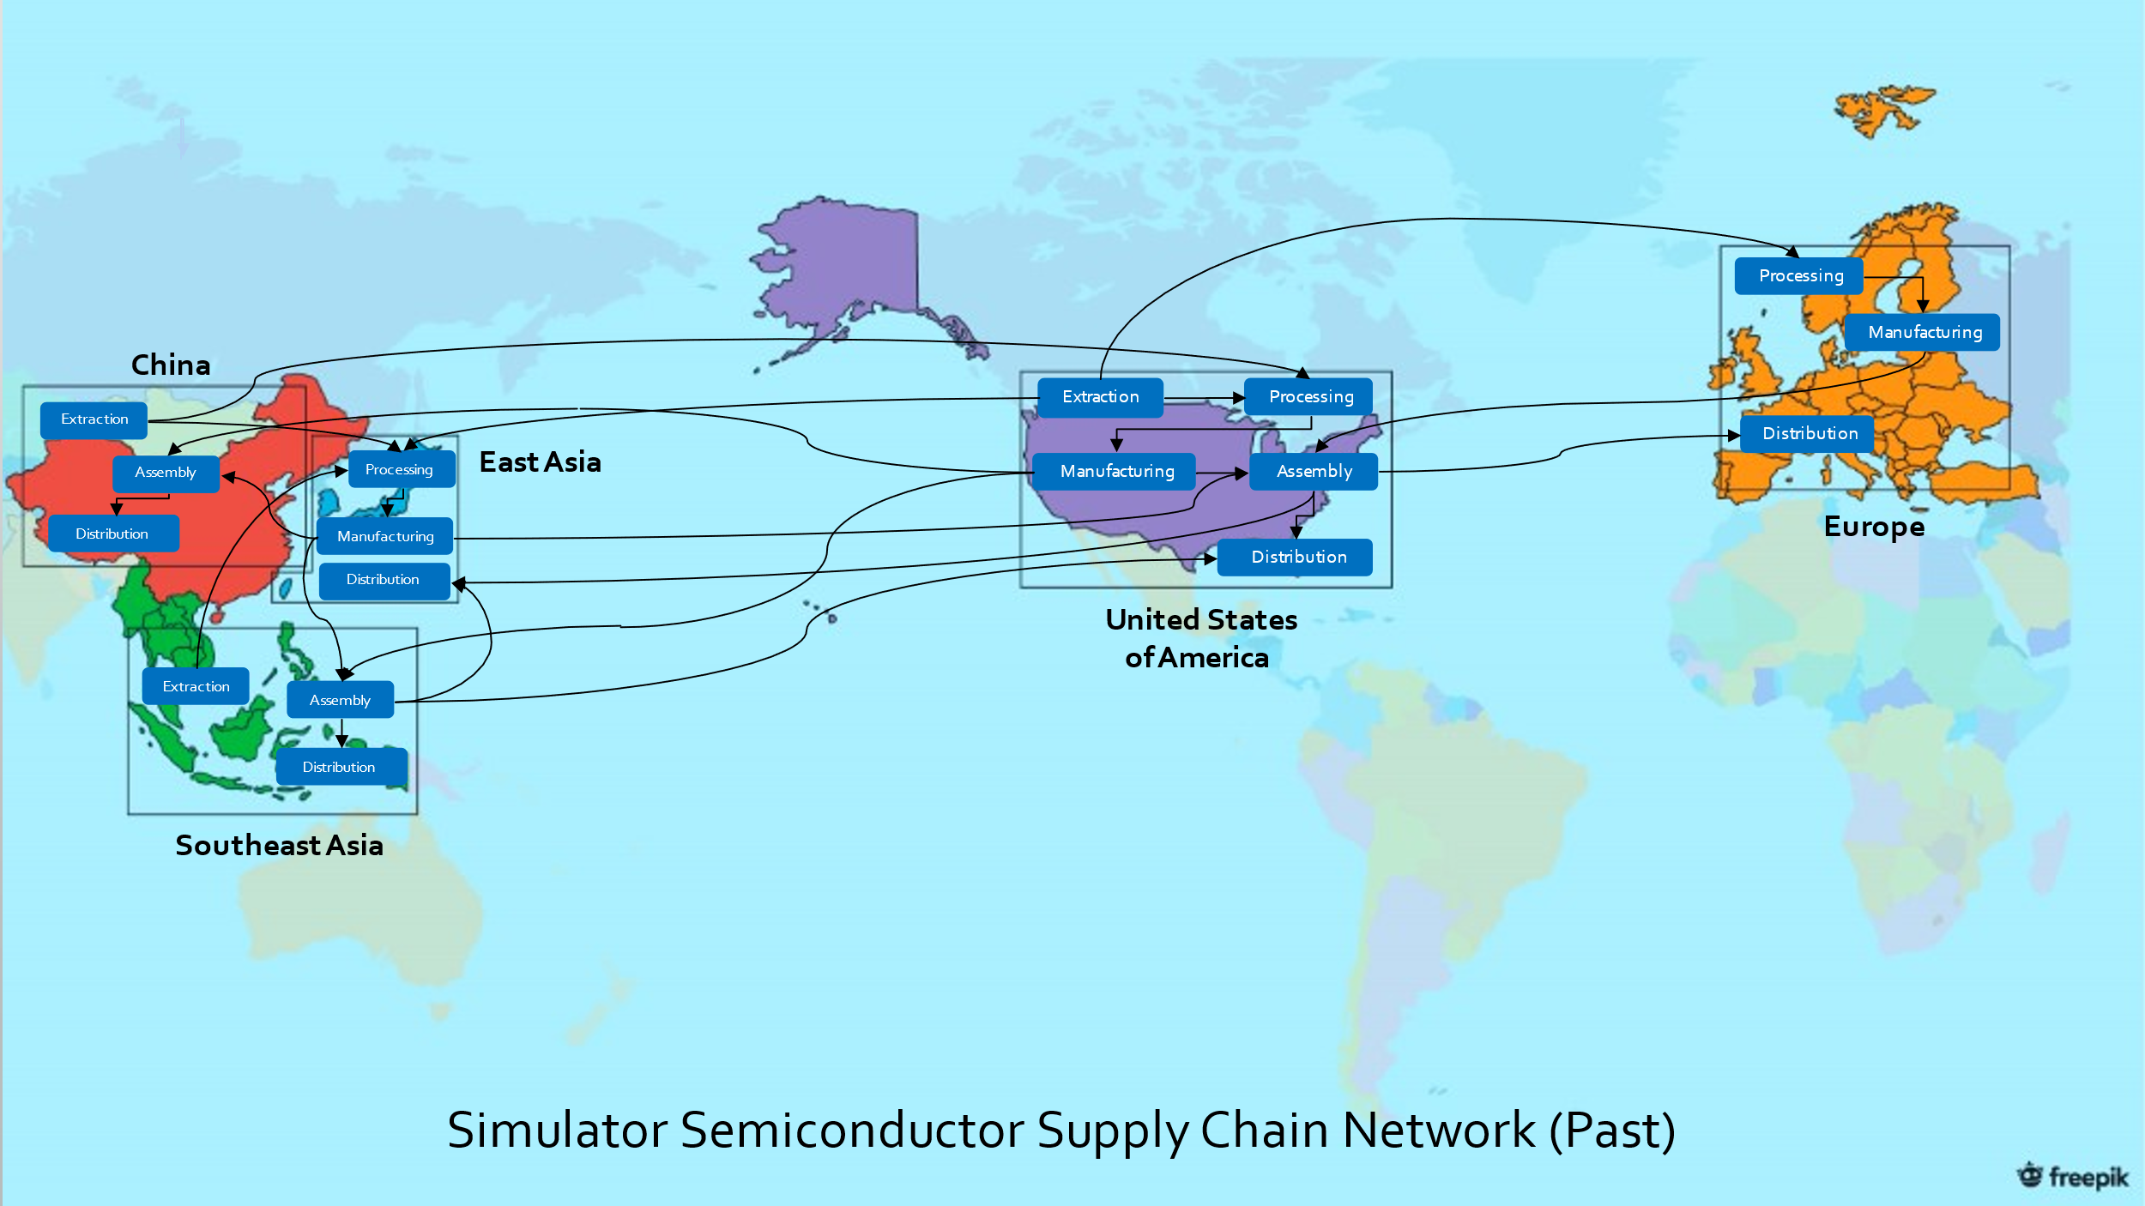

Figure Diagram of inter-process supply chain connections of Past Simulation

Following the above diagram of supply chain connections, the Past Simulation is constructed as such on JaamSim:

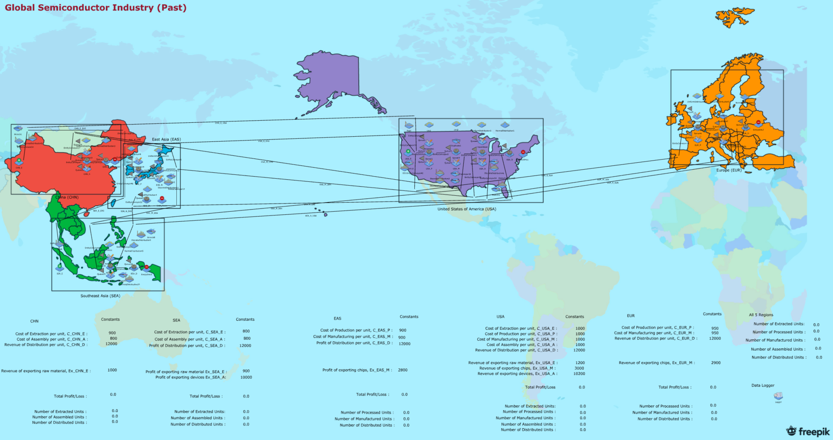

Figure Past Simulation on JaamSim

## Future Simulation Supply Chain Network

With the intervention of intellectual property theft of China from the United States, China advances its capabilities in the processing and manufacturing of semiconductors. With the banning of imports and exports of semiconductor goods of China from the Unites States and US-related companies (that are in East Asia), China also has its supply chain flows cut off from those regions. Southeast Asia is assumed to be an ally of China in this Simulation, forming new trade links with China and having its trade links cut off from East Asia and the United States as well. The Future Simulation simulates this scenario and is constructed as such: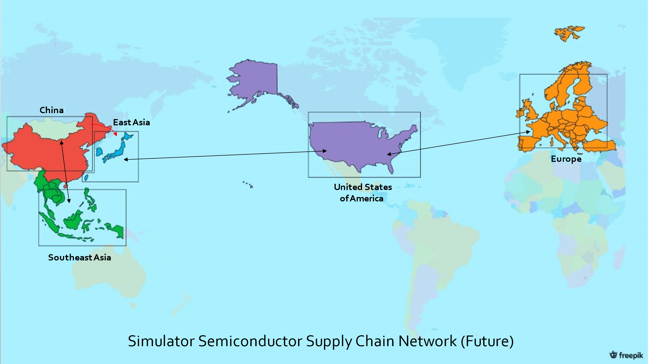

Figure Diagram of inter-region supply chain connections of Future Simulation

The connection of Semiconductor Supply Chain Processes within and between each region is as follows:

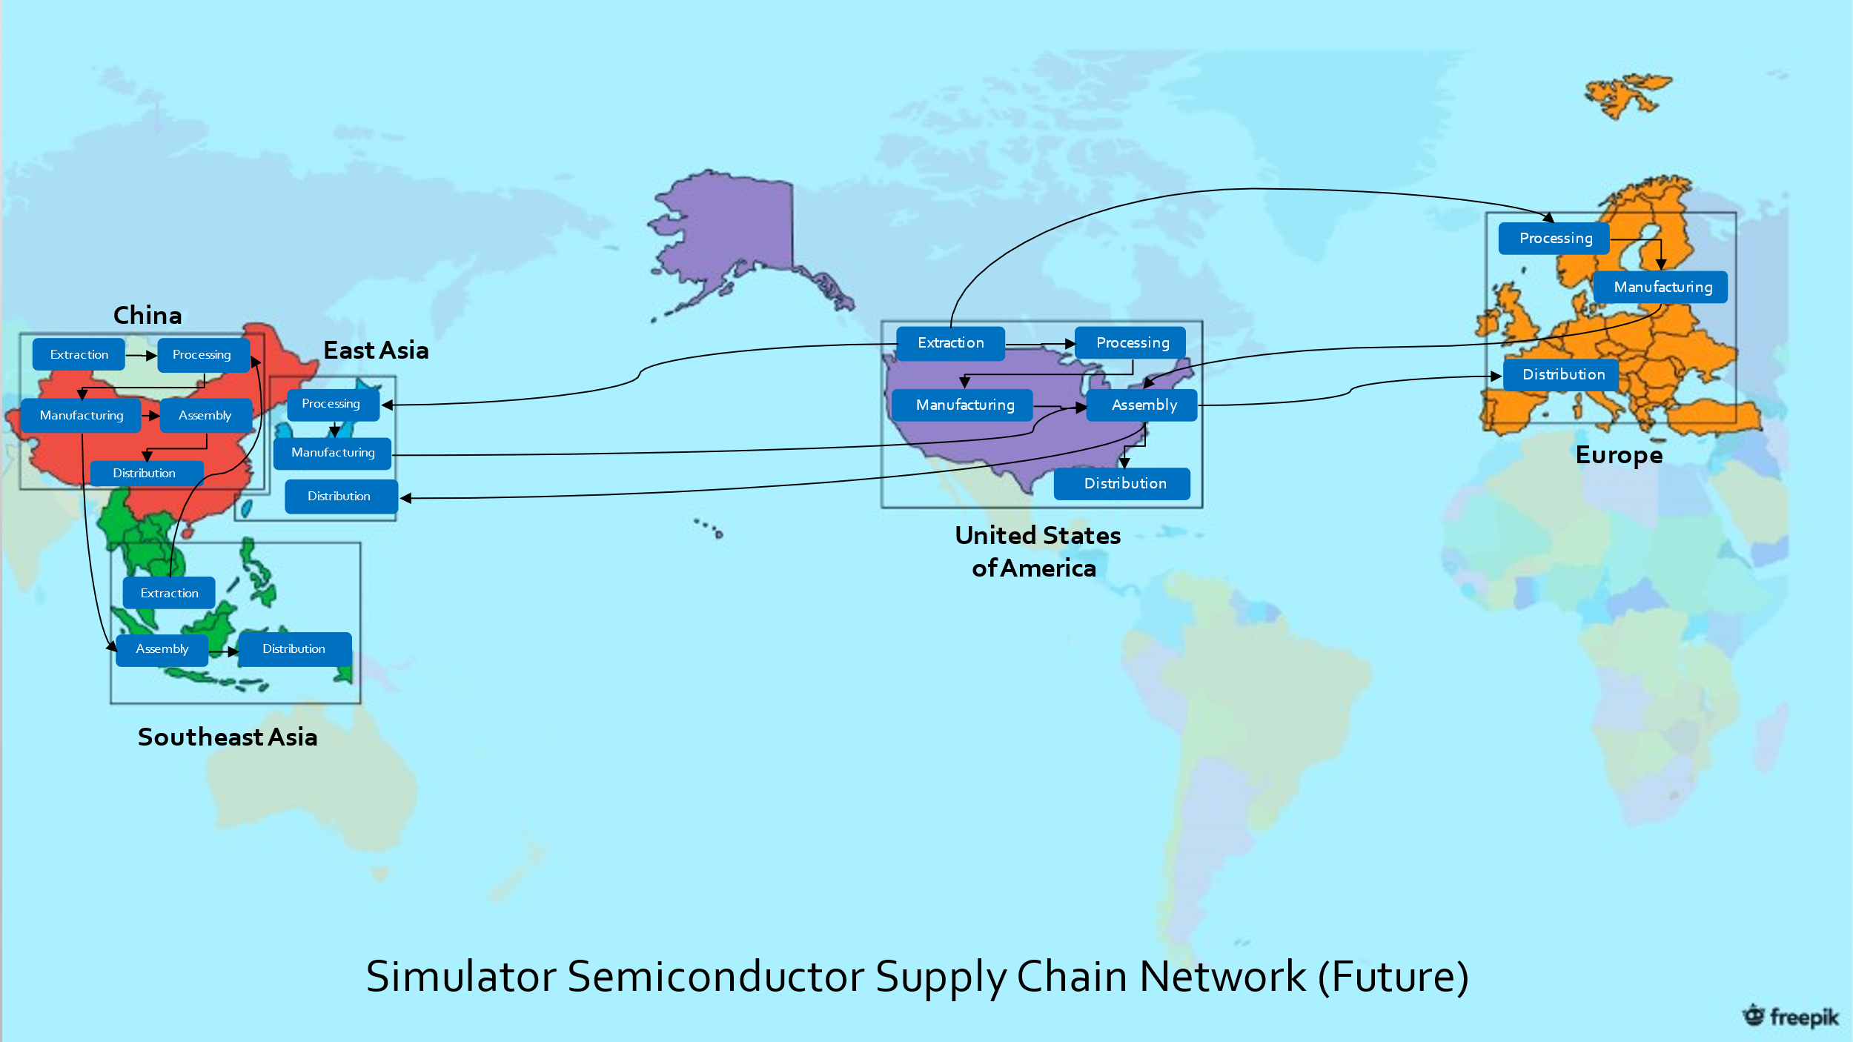

Figure Diagram of inter-process supply chain connections of Future Simulation

Likewise, following the above diagram, the Future Simulation on JaamSim is constructed as such:

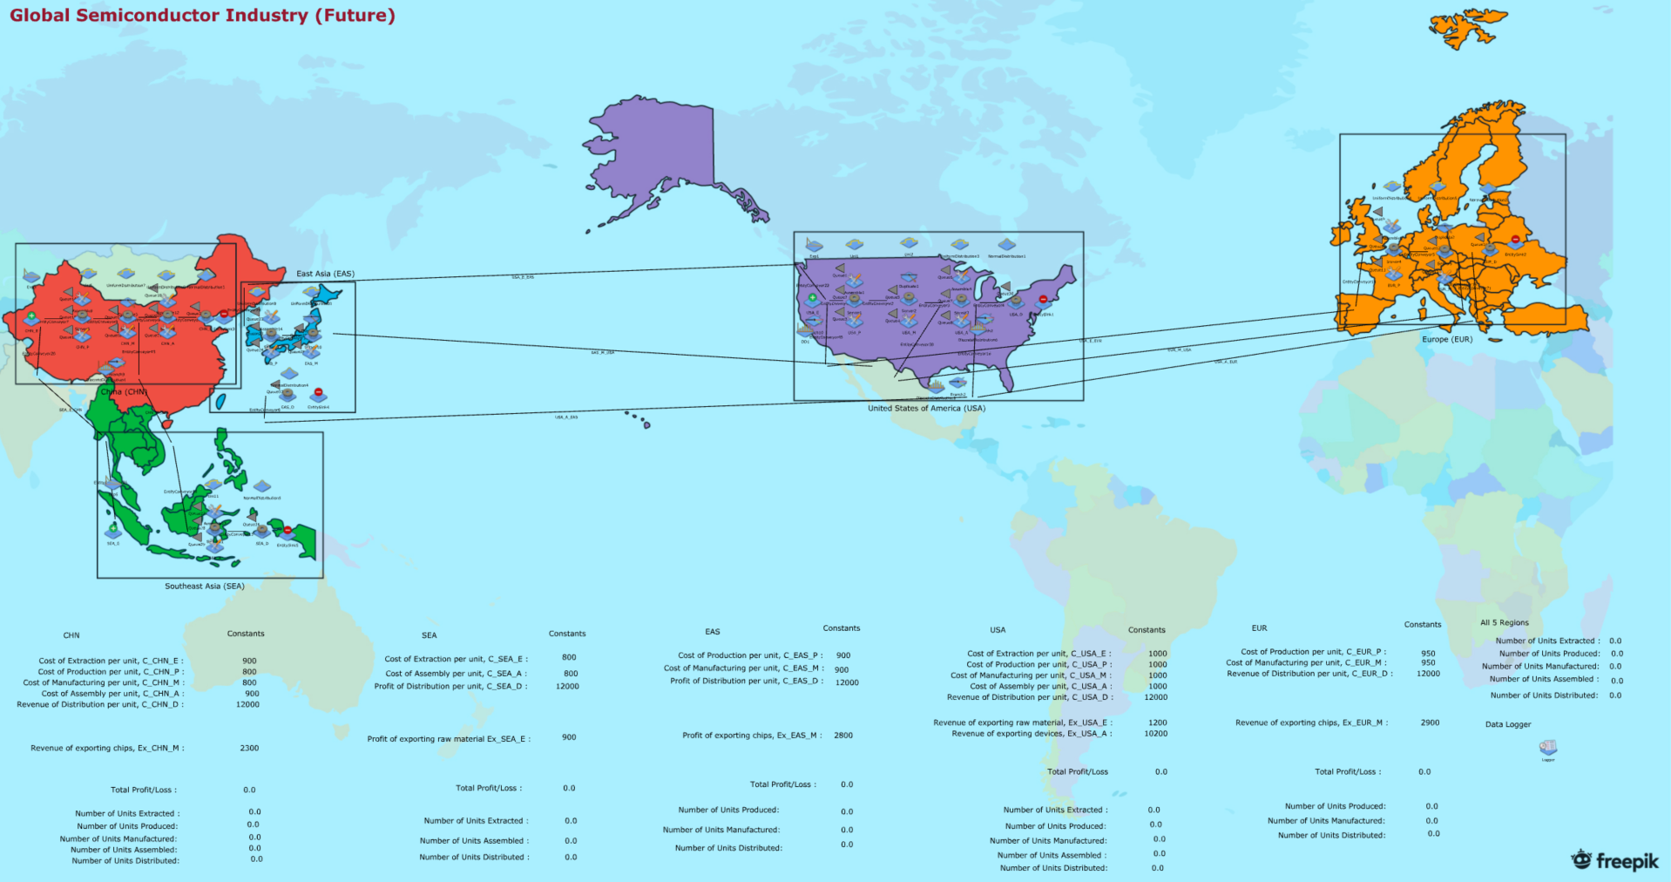

Figure Future Simulation on JaamSim

Do refer to the JaamSim Configuration files, “semiconductor_industry_past” and “semiconductor_industry_future” for the past and future simulations respectively.

# Data Collection

To analyse the simulation, data of monthly profits from each region is being calculated and logged for analysis. The profits are calculated by summing the production costs, export revenue and import revenue. The profits are calculated as such:

$$Profit_{i}=-Total Production Costs+Total Export Revenue-Total Import Costs$$

$$=-\sum_{all n}{c_{i,n}M_{i,n}}+\sum_{all e}{r_{out,i,e}T_{out,i,e}}-\sum_{all j}{r_{in,d,j}T_{in,d,j}}$$

Where:

* i: index for the local region (i.e. USA, CHN, EUR, etc)
* n: index for processes of the local region (i.e., extraction, manufacturing. etc).
* e: index for processes from which goods are exported.
* j: index for processes from which goods are imported from another region.
* d: index for region from which goods are imported from.
* $c_{i,n}$: Production costs process i for producing 1 unit product for the process n.
* $M_{i,n}$: Total number of unit outputs produced locally in process n of the local country i.
* $T_{out,i,e}$: Total number of units being exported by the local region i from process e.
* $T_{in,d,j}$: Total number of units being imported from another region d from process j
* $r_{out,i,e}$: Revenue for exporting a single of unit of product from process e in country i.
* $r_{in,d,j}$: Cost for importing a single of unit of product from process j in region d.

Zero shipping fee is assumed so the export revenue from one country is the importing costs for the receiving country.

In calculating the costs, a cost value $c_{i,n}$  is assigned to every process in each region, and an export revenue $r_{out,i,e}$  is assigned to each process from which the products are being exported to another region. The cost values ($c_{i,n}$)re determined based on collected data, and tweaked to factor in the ratio of products being produced in each process to ensure a fair cost value for each process. On the other hand, the export values ($r_{out,i,e}$) are determined by adding a certain profit margin to the total costs associated with the production processes and importing of the goods to produce the product.

Below is a table with the breakdown of the production costs and export revenues:

## Production costs and Export Revenues:

* China (CHN)
 $C_{CHN,E}=900$

 $C_{CHN,P}=800$

$C_{CHN,M}=800$ + [For Future Simulation only]
 $C_{CHN,A}=900$

 $C_{CHN,D}=-12000*$

$Ex_{CHN,E}=1000$

$Ex_{CHN,M}=2300$ + [For Future Simulation only]
* Southeast Asia (SEA)
 $C_{SEA,E}=800$

 $C_{SEA,A}=800$

$C_{SEA,D}=-{12000}^{*}$

$Ex_{SEA,E}=900$

$Ex_{SEA,A}=10000$ + [For Past Simulation only]
* East Asia (EAS)
$C_{EAS,P}=900$

$C_{EAS,M}=900$

$C_{EAS,D}=-12000*$

$Ex_{EAS,M}=2800$

* United States of America (USA)
 $C_{USA,E}=1000$

 $C_{USA,P}=1000$

$C_{USA,M}=1000$

$C_{USA,A}=1000$

$C_{USA,D}=-{12000}^{*}$

$Ex_{USA,E}=1200$

$Ex_{USA,M}=3000$ + [For Past Simulation only]
$Ex_{USA,A}=10200$

* Europe (EUR)

$C_{EUR,P}=950$

$C_{EUR,M}=950$

$C_{EUR,D}=-{12000}^{*}$

$Ex_{EUR,M}=2900$

*Note: Process cost for Distribution is negative as each country gains revenue from distribution.

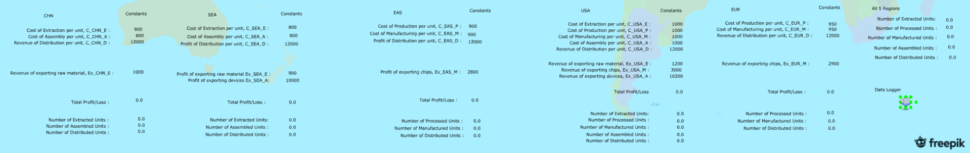

Figure Snippet of Monthly Profits Calculation from Simulation

In the JaamSim Simulation, the details of the calculation of the monthly profits are illustrated at the bottom. The various costs values of each production process, total profit/loss and number of units being produced from each production process of each Region can be viewed as the simulation progresses. The data is computed and saved by the Data Logger, which outputs a text file of the monthly profits of each region.

## Simulation Data Logging

In logging data from the simulation, the simulation is run for 1000 years, from which the monthly profits of each region are logged and saved.

As the Simulation has been designed such that 1 simulated second is intended to represent 1 day in the Simulated Semiconductor Supply Chain, the Simulation is set to run for 365000 seconds (representing 1000 years in the simulation) from which the cumulative profits are recorded every 30 seconds (every 30 days, representing 1 month in the simulation).

As the data logged from the Simulation is cumulative profits of each region, the data is being cleaned and processed on Microsoft Excel to get the monthly profits. An additional column, “Total” is also calculated by calculating the sum of profits across all 5 regions in each month.

# Data Analysis

After logging and processing from the simulation, the data of monthly profits of both past and future data are now cleaned and ready for analysis. The objective of this analysis is to assess if there is any statistically significant difference in the mean monthly profits between the past and future of each region. This would help us assess the significance of the impact of the Geopolitical Intervention on the Global Semiconductor Economy of the Simulation.

The Data Analysis is executed in R and can be viewed in the file “Semicon_Simulation.html” in the Data Analysis folder.

## Exploratory Data Analysis

Through exploring the data, 2 problems were found:

1. There is an initialization bias in both past and future time series datasets.
2. There is very high variance in both datasets, making it difficult to do statistical tests on the data alone.

This can be seen through the visualizations of the Total Profits of all 5 regions in both Past and Future scenarios.

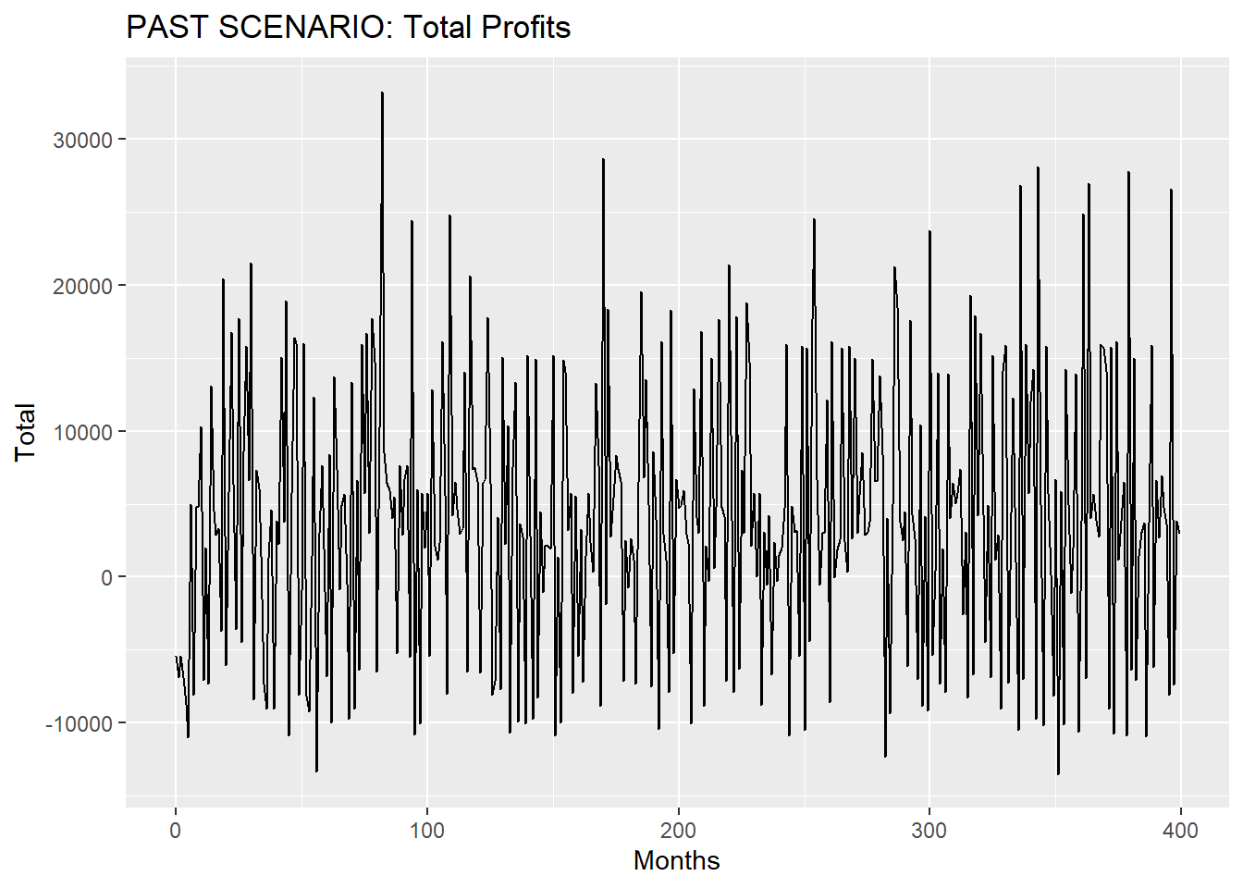

Figure 10 Past Scenario: Monthly Total Profits of all 5 regions

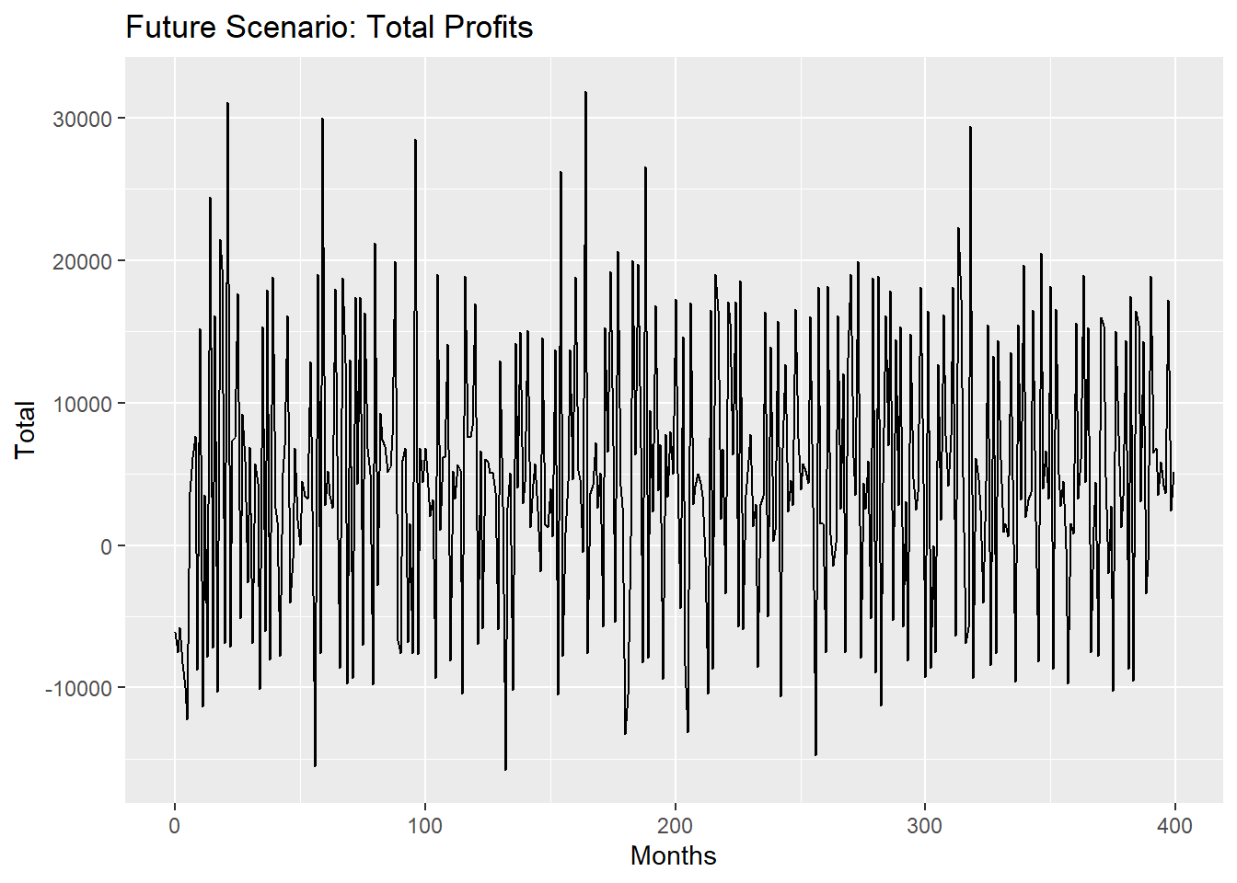

Figure Future Scenario: Monthly Total Profits of all 5 regions

To overcome this, the datasets of all regions in both past and future simulations are visualized to determine the burn-in periods. Through the visualizations, a burn-in period of 20 months is identified and removed from the data. (Refer to Semicon_Simulation.html for more details)

To reduce the variance and analyse the time series datasets, a Batch Means Approach is used. We split up the time series data into 1000 batches of 12 data points. As each observation represents 1 month, each batch will represent 1 year in the simulation. By applying a Batch Means approach to analyse the Time Series data, the average monthly profits of each year in the Simulation is retrieved. Treating each year in the simulation as an independent, 2 samples of 1000 average monthly profits of each year for both Past and Future scenarios are computed for hypothesis testing.

The means and variances are then calculated to get a good estimate of the parameters of the monthly profits of each year.

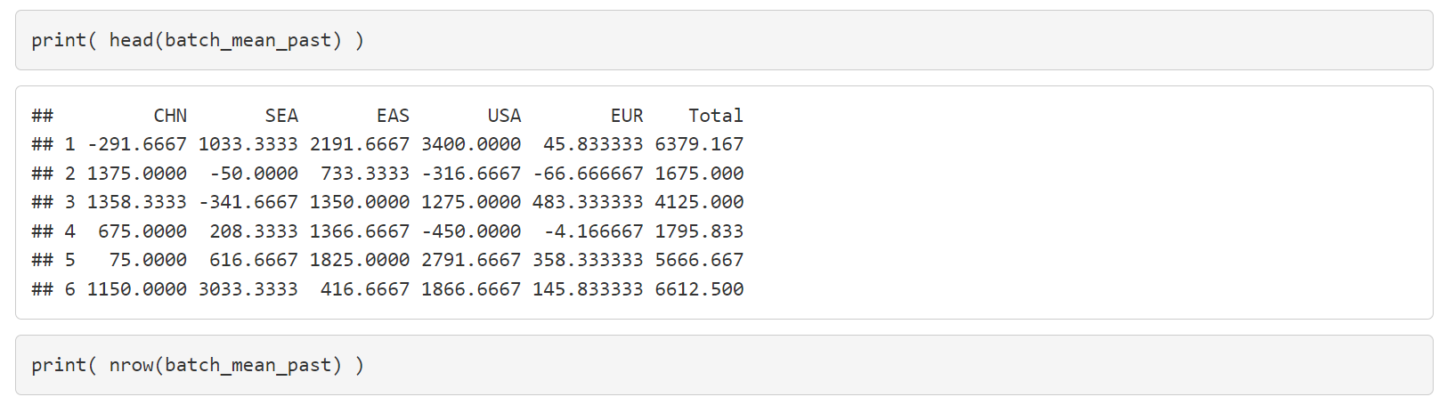

Figure Snippet of Batch Means Approach applied on the past dataset

## Hypothesis Testing

With the samples of batch means monthly profits from both past and future simulations without any initialization bias, it is now easier to do Hypothesis Testing with the reduced variance.

2 Sample T-tests are conducted for the data of all regions as well as the Total Month Profits of all regions. The Hypothesis test is constructed as such:

$$Let μ_{1i} represent the past mean monthly profits of the i^{th} region and$$

$$μ_{2i} represent the future mean monthly profits of the i^{th} region.$$

$$Constructing the hypothesis test for region i:$$

$$H_{0}:μ_{1i}-μ_{2i}≠0$$

$$H_{1}:μ_{1i}-μ_{2i}=0$$

Through the Hypothesis Testing, we arrive at the conclusion that, after the Geopolitical Intervention, both China and Southeast Asia has had significant increase in profits, while United States and Europe had a significant decrease in profits. (Refer to Semicon_Simulation.html for more details)

## Percentage Change in profits

The percentage changes in profits of all 5 regions, as well as the Monthly Total Profits of all 5 regions are as follows:

* China: 238.15%
* Southeast Asia: 86.35%
* East Asia: -91.29%
* United States: -54.16%
* Europe: 4.47%
* Total: 7.8%

Looking at the results, China profited the most through the event, while East Asia suffered the most losses.

With the highest increase in profits of 238.15%, more than triple its previous monthly profits, China stands out in the simulation to show the benefits of advancing its own capabilities in the production of Semiconductors. Through setting up **i**ts Semiconductor Production and Manufacturing Capabilities, the data shows that its reduced reliance on other countries would cause a significant boost to its economy.

It is interesting to note that East Asia suffered the most losses after the Geopolitical Intervention, with a very large proportion of its profits, 91.29%, being lost after the event. This makes sense because East Asia has been producing and manufacturing Chips for China and Southeast Asia in the past simulation. When it had its trade links cut off from these 2 regions, its only remaining business partner was the United States. Therefore, losing 2 of its previous trading partners took a huge toll to on the economy of East Asia.

On the other hand, despite having trade links cut off from the United States and East Asia, Southeast Asia benefitted with a generous 86.35% increase in profits after the event. With China setting up its own Processing and Manufacturing capabilities, it then becomes cheaper for East Asia to outsource the Production and Manufacturing of its Semiconductors to China, thus leading to the increased profits.

For Europe, there is a 4.47% increase in monthly profits, which, based on the Hypothesis Tests, is insignificant and can be ignored. This makes sense because the Simulation has been designed such that the Geopolitical Intervention would have little effect on the inflow and outflow of goods from Europe in the Semiconductor Supply Chain.

Looking at the Total Monthly profits across all regions, a positive increase of 7.8% is observed. This increase shows that the increase in profits from China outweighs the losses incurred in the other regions. This also means that, despite the termination of Trade Links, the overall Semiconductor Supply Chain becomes more efficient as it is now generally cheaper to produce and manufacture chips from China.

As the Simulation is unrealistic, results from this Simulation should be taken with a pinch of salt, and rather be used as a means to better understand the impact of the Geopolitical Intervention on regional trade links within the Global Semiconductor Supply Chain.

# Conclusion

In this project, the Global Semiconductor Supply Chain is simulated on JaamSim, illustrating regional trade links between five regions in the economy on a basic process flow of the production of Semiconductors. In assessing the impact of the Geopolitical Intervention of the US-China Trade war, 2 scenarios of the simulation were created, each representing the Global Semiconductor Economy before and after the intervention. Through data analysis, the significance and magnitude of the impact on the monthly profits is realized and can be understood through the changes in trade links after the Simulation. All in all, despite the unrealistic nature of the Simulation, it can be used to understand how disruptions in Supply Chain Trade Links can have significant impacts on different regions in the Global Supply Chain.

# Bibliography

Ellis, S. (2023, February 7). *Why China is losing the microchip war*. Retrieved from Youtube: https://www.youtube.com/watch?v=Uh4QGey2zTk

*Engineer Who Fled Charges of Stealing Chip Technology in US Now Thrives in China*. (2022, June 6). Retrieved from CSET: https://cset.georgetown.edu/article/engineer-who-fled-charges-of-stealing-chip-technology-in-us-now-thrives-in-china/

Harris, J. (2023, January 18). *USA vs China, The War You Can't See*. Retrieved from Youtube: https://www.youtube.com/watch?v=k_zz3239DA0

Jordan Robertson, & Michael Riley. (2022, June 6). *Engineer Who Fled Charges of Stealing Chip Technology in US Now Thrives in China*. Retrieved from BNN Bloomberg: https://www.bnnbloomberg.ca/engineer-who-fled-charges-of-stealing-chip-technology-in-us-now-thrives-in-china-1.1774889

Mattingly, P. (2022, October 7). Retrieved from CNN Politics: https://edition.cnn.com/2022/10/07/politics/china-us-semi-conductor-chips/index.html